Note from the United Kingdom of 9 August 2021

Subject: Images of the European Health Insurance Cards (EHIC) and Global Health Insurance Cards (GHIC) circulated by the UK Government

The UK presented a note (A.C. 051/21) which set out the UK Government’s steps on implementing the social security coordination provisions of the Withdrawal Agreement and the Protocol on Social Security Coordination of the EU – UK Trade & Cooperation Agreement. This note provides the relevant images for the UK-issued Health Insurance Cards in circulation, as requested by the Administrative Commission secretariat.
The UK has provided a similar notification to the Specialised Committee on Social Security Coordination, as per the obligations set out in the Protocol on Social Security Coordination.

United Kingdom cards in circulation
Card | Current legal basis | Validity Period | Valid in
CRA EHIC (issued from November 2020) | Citizens’ Rights Agreement (of the Withdrawal Agreement) | 5 years | EEA and Switzerland
Student CRA EHIC (see below) | Citizens’ Rights Agreement (of the Withdrawal Agreement) – in country of study  Social Security Protocol of the EU – UK Trade and Cooperation Agreement | Length of study | In country of study (EEA & Switzerland)  EU 27
UK EHIC (without EU stars, issued since February 2020) | Social Security Protocol of the EU – UK Trade and Cooperation Agreement | 5 years | EU27
UK EHIC (with stars, issued up to 31 January 2020) | Social Security Protocol of the EU – UK Trade and Cooperation Agreement | 5 years | EU27
GHIC (UK branding) | Social Security Protocol of the EU – UK Trade and Cooperation Agreement | 5 years | EU27
GHIC (neutral design, available to residents of Northern Ireland) | Social Security Protocol of the EU – UK Trade and Cooperation Agreement | 5 years | EU27

Student CRA EHIC
The Withdrawal Agreement student EHICs are distinguished by country specific text in the PIN and should continue to be accepted by healthcare providers in that Member State as evidence of an individual’s entitlement to necessary healthcare under the Withdrawal Agreement.
In addition, given students also have rights under the Protocol, we ask that under Article SSCI.75 of the Protocol, those new student CRA EHICs are accepted by healthcare providers in all other EU Member States as evidence of an individual’s entitlement to necessary healthcare. The Specialised Committee on Social Security Coordination have also been notified.

CRA EHIC (issued from November 2020)
Current legal basis: Citizens’ Rights Agreement (of the Withdrawal Agreement)
Validity Period: 5 years
Valid in: EEA and Switzerland

FRONT
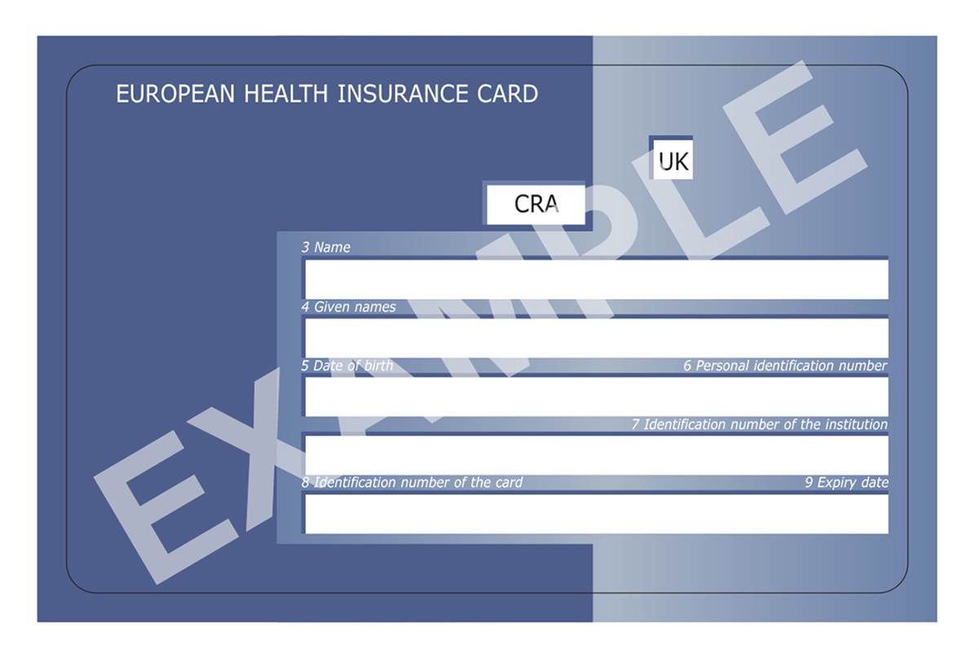

BACK
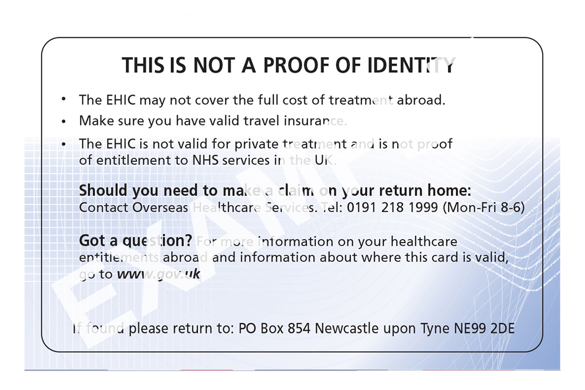

Student CRA EHIC
Current legal basis:
- Citizens’ Rights Agreement (of the Withdrawal Agreement) – in country of study which is specified in the Personal Identification Number
- Social Security Protocol of the EU – UK Trade and Cooperation Agreement
Validity Period: Length of study
Valid in:
- In country of study (EEA & Switzerland)
- EU 27
FRONT
BACK
UK EHIC (without EU stars, issued since February 2020)
Current legal basis: Social Security Protocol of the EU – UK Trade and Cooperation Agreement
Validity Period: 5 years
Valid in: EU27

FRONT
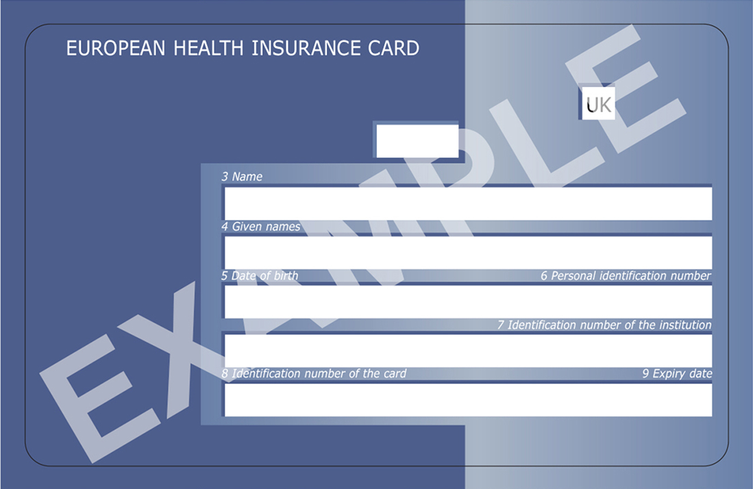

BACK
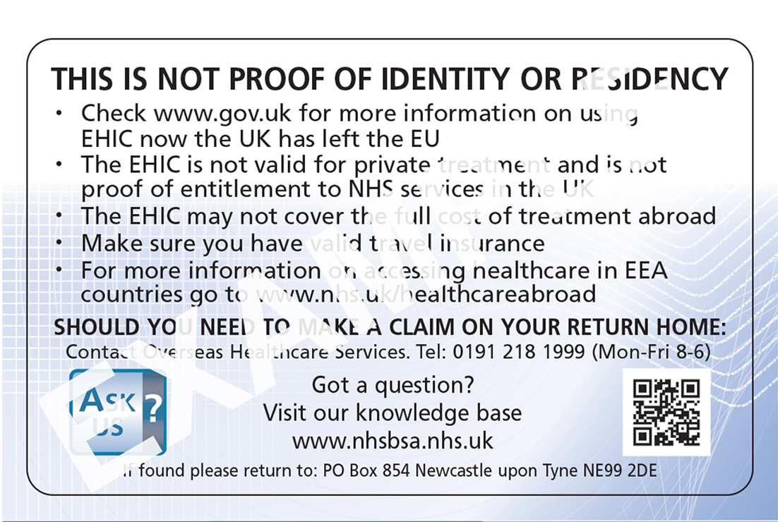

UK EHIC (with stars, issued up to 31 January 2020)
Current legal basis: Social Security Protocol of the EU – UK Trade and Cooperation Agreement
Validity Period: 5 years
Valid in: EU27

FRONT
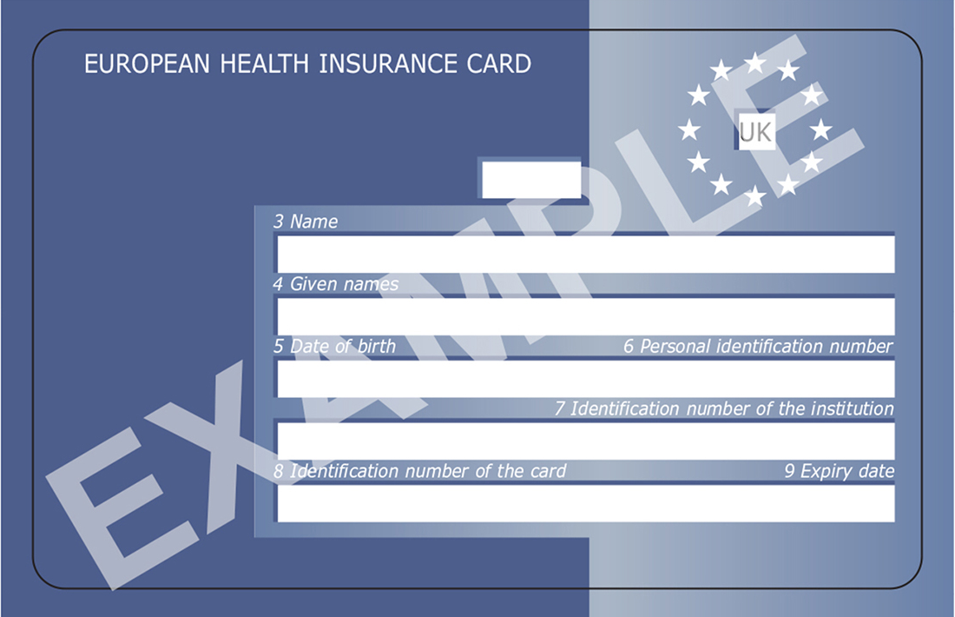

BACK
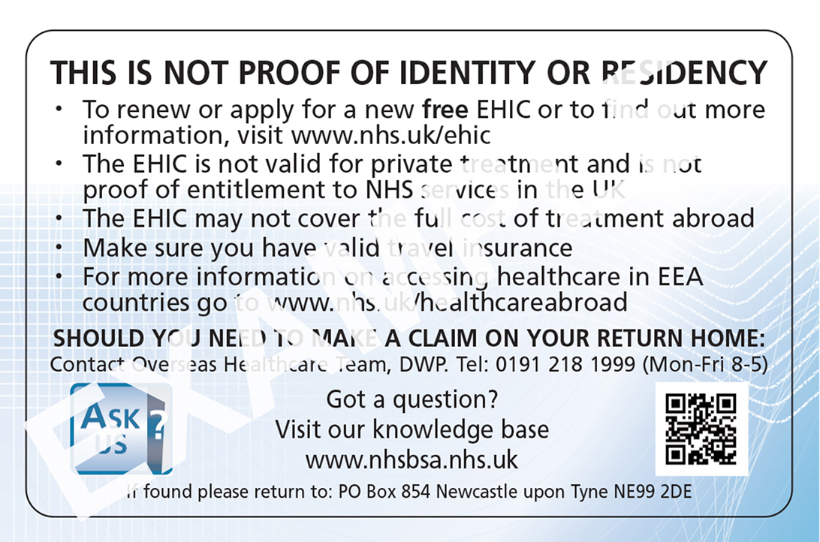

GHIC (UK branding)
Current legal basis: Social Security Protocol of the EU – UK Trade and Cooperation Agreement
Validity Period: 5 years
Valid in: EU27

FRONT
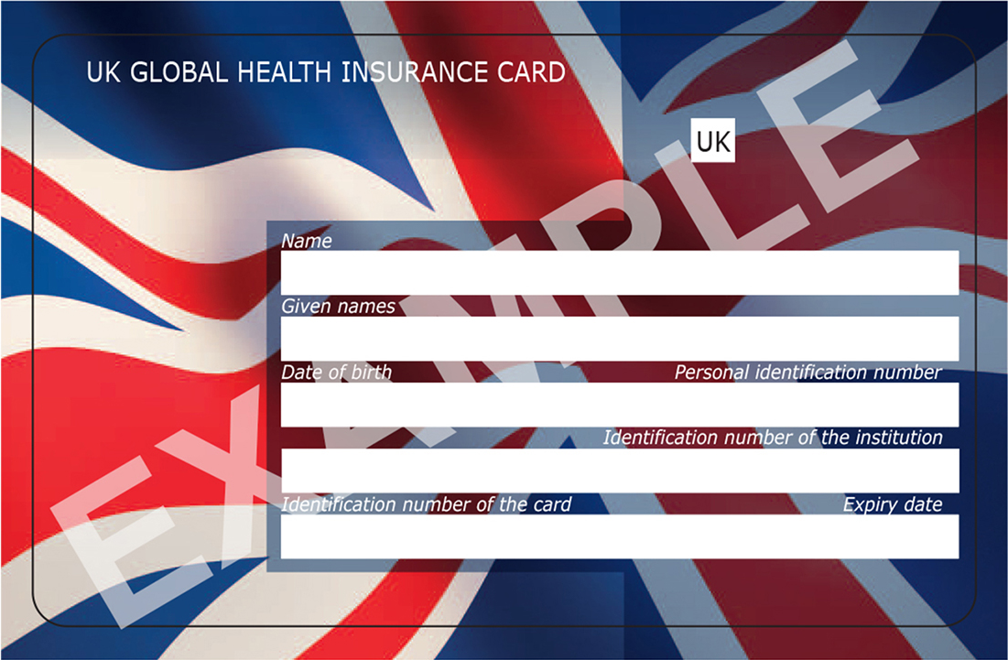

BACK
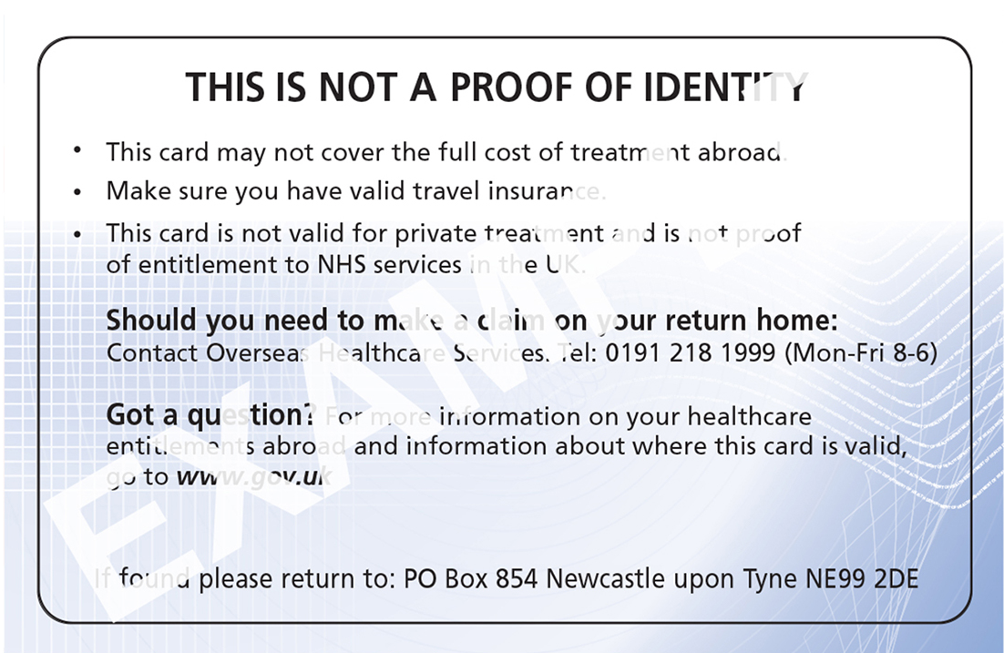

GHIC (neutral design, available to residents of Northern Ireland)
Current legal basis: Social Security Protocol of the EU – UK Trade and Cooperation Agreement
Validity period: 5 years
Valid in: EU27

FRONT

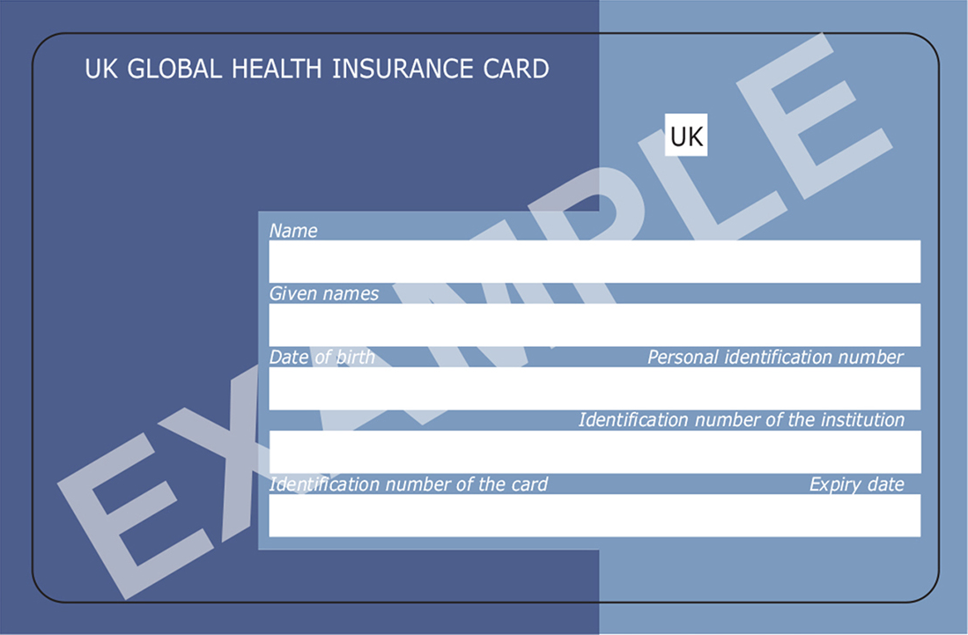

BACK
